# Preschool

**Screening**

We have been screening the children since our return in July and will continue until further notice. All returning parents must *complete the screening forms on line each and every morning* prior to coming to Phoenix. The screeners will check your responses, take your child’s temperature, clean belongings and ask your child/ren to clean their hands before entering classrooms. The screening area is at exit 4. Only Phoenix children will be screened upon entry and again before entering afternoon programs. We believe that our safety protocols will keep our staff and children safe while at daycare.

Phoenix recommends that all children (including preschool) were a mask. If young children are not able to wear their mask safely, we will remove them and try again at a later time. Seneca Hill is asking that all children, Kindergarten through grade 5 wear a mask when in classrooms and hallways. Please send 2 masks for you child. In Phoenix masks will be kept in labelled paper bags. Toronto Public Health recommends keeping masks in a paper bag, as a result we are asking parents to provide 2 paper bags labelled clean and dirty with your child’s name printed clearly.

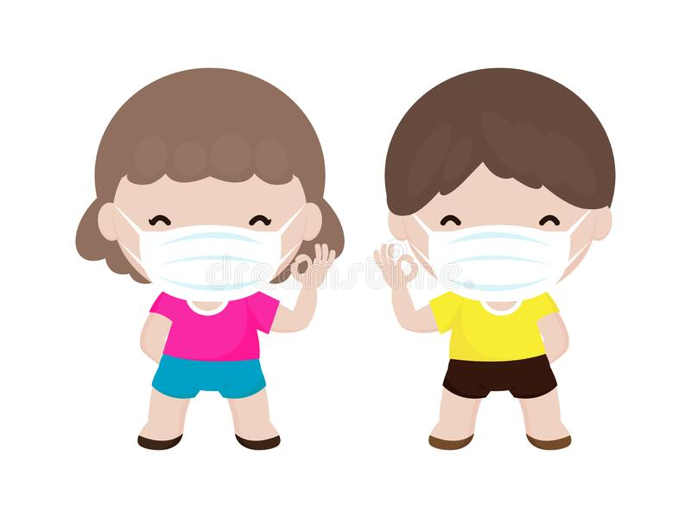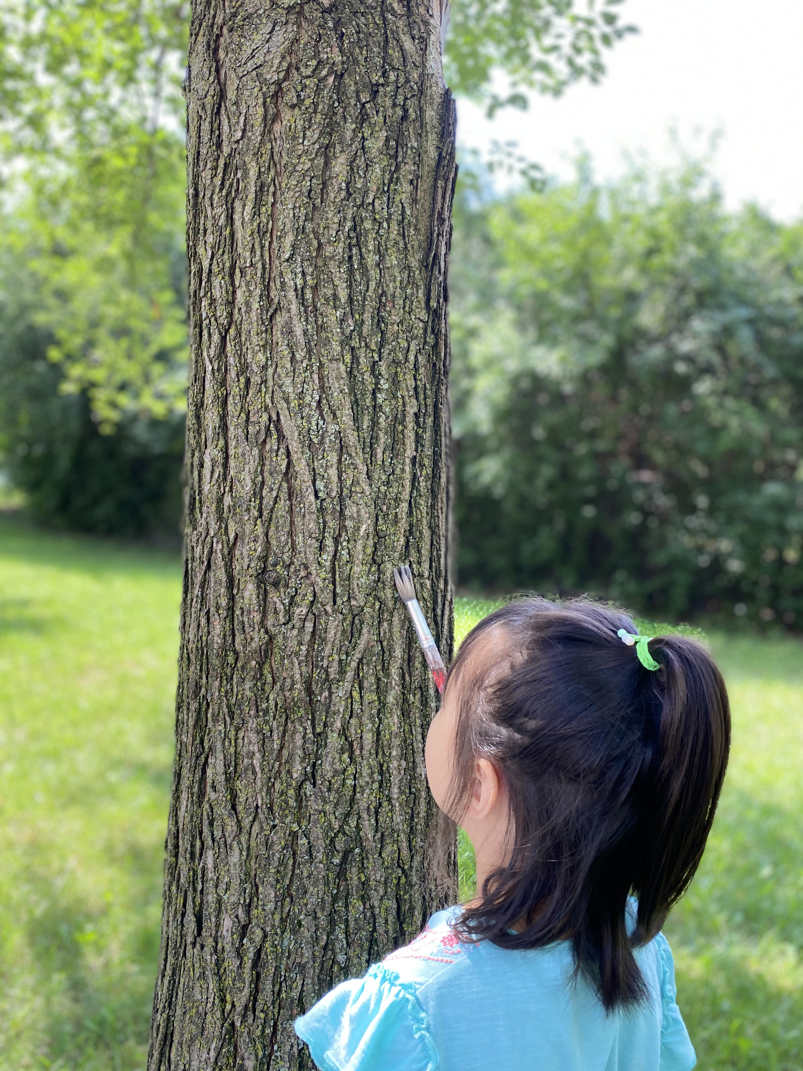

**What Will September Look Like?**

I’m sure you’ve all been wondering how we can possibly continue to provide emergent, project based curriculum given the health and safety measures in place during COVID. To be honest, we wondered too! We have spent the summer perfecting our interactions, safety measures and have gotten pretty creative to ensure the children are well cared for, safe and fully engaged in learning opportunities. We have concerned ourselves with making sure the children feel a sense of belonging and control even amongst all of our new protocols. We remain committed to observing children’s play patterns and providing opportunities to extend and explore areas of interest and inquiry. Having fewer children allows us to delve deeply into project work and to spend more time outside appreciating all of the opportunities to learn about the mysteries mother nature has given us. COVID has made us look at ***outdoor exploration*** through a new lens, as an extension of our classroom. As always we will share documentation with you as projects develop.

#### Staying Safe at Phoenix

# Wearing Masks

Welcome Back



Phoenix Child Centre

September 2020

Volume 1, Issue 1

Phoenix Child Centre Newsletter

Greetings! Qian and I (Quang) are excited to welcome our families back and to deliver an exciting project based program. As always we will follow the children’s lead, observe interactions and formulate projects based on their areas of inquiry. As a result of COVID we will also focus on social distancing, mask wearing, hand washing and respecting the rights of others. We hope you had a wonderful summer and are ready for an exciting, albeit different Fall.

We are so excited to introduce our new web site at *www. phoenixchildcentre.ca*. Please visit when you get an opportunity and set-up your parent password in the “parent” portion of the site. Here your will find exclusive information available to Phoenix parents only. New families will be able to access our registration forms here as well.

We look forward to your feedback!



#### New Web Site

.

Welcome back to Phoenix FDK 2 (Grade 1)! This fall we will focus on, introductions to our new safety protocols in our new classroom. We will extend our learning outside and enjoy a nature based program by bringing the indoors out! Children must be dressed according to the weather and bring an extra change of clothing as we will get down and dirty outside! Social distancing, masks and hand washing are an important component of our COVID safety measures, we will be observing the children carefully to ensure they are following new health and safety regulations. Teachers will be wearing masks and goggles when in classroom areas and hallways to protect themselves and the children from transmission.

# FDK 2

Welcome to the preschool room! We look so forward to having you back or meeting you for the first time! The preschool staff and children have been busy this summer getting used to all the new guidelines inside and outside of the classroom. We have been working diligently on giving people space. We have noticed that the children need to be reminded to socially distance on a frequent basis. It is a challenge to keep preschoolers apart when they are consumed by having fun! In the classroom, markings on the floors and furniture serve to remind the children to keep apart. Each area has been labelled with the number of children allowed to play. We have been using visual reminders to support understanding of new rules.

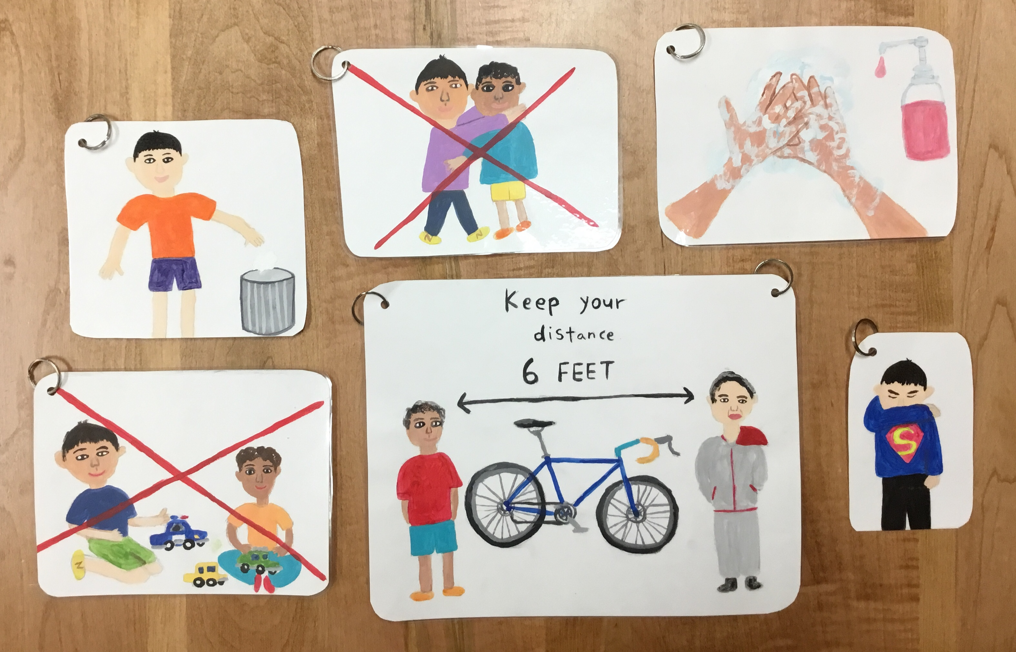

## FDK 1

Welcome FDK families! We have missed everyone and are looking forward to returning to some semblance of “normal”.

In light of COVID, we will be spending our first week revisiting routines and introducing our new COVID rules of social distancing, masks and hand washing. Each child has an assigned cubby and bin. Each bin contains all the materials they will need during their time in class and are not to be shared with anyone.

Please ensure your child has:

* Backpack with water bottle/sunscreen
* Indoor/outdoor shoes/extra clothes
* Hat/2 face masks

Please be reminded that Phoenix closes at 6, a late fee is charged for parents arriving after closure. Christine, Mary Joy

Phoenix Newsletter Page 2

# Preschool

## School Age